**DAILY ONLINE ACTIVITIES SUMMARY**

|  |  |  |  |  |  |  |  |
| --- | --- | --- | --- | --- | --- | --- | --- |
| **Date:** | **05 June 2020** | | | | **Name:** | **KHATHEEJA SAFREENA** | |
| **Sem & Sec** | **4th sem, 2nd year** | | | | **USN:** | **4AL18CS037** | |
| **Online Test Summary** | | | | | | | |
| **Subject** | | **------** | | | | | |
| **Max. Marks** | | **-----** | | **Score** | | **------** | |
| **Certification Course Summary** | | | | | | | |
| **Course** | **GAME DEVELOPMENT USING PYGAMES.** | | | | | | |
| **Certificate Provider** | | | **GUVI** | **Duration** | | | **7 Hours** |
| **Coding Challenges** | | | | | | | |
| **Problem Statement:1 program** | | | | | | | |
| **Status: Executed** | | | | | | | |
| **Uploaded the report in Github** | | | | **Yes** | | | |
| **If yes Repository name** | | | | [http://shafreenasharief / lockdown-coding](http://shafreenasharief / lockdown-coding" \o "http://shafreenasharief / lockdown-coding)  [http://shafreenasharief / locked-down--certification-course](http://shafreenasharief / locked-down--certification-course" \o "http://shafreenasharief / locked-down--certification-course)  [http://shafreenasharief / Daily\_Report](http://shafreenasharief / Daily_Report" \o "http://shafreenasharief / Daily_Report) | | | |
| **Uploaded the report in slack** | | | | **Yes** | | | |

Certification Course Details: (Attach the snapshot and briefly write the report for the same)

Coding Challenges Details: (Attach the snapshot and briefly write the report for the same)

**CERTIFICATION COURSE SUMMARY:**

* Today I continued with GAME DEVELOPMENT BY PYGAME.Pygame is a python wrapper for SDL– a cross-platform C library for controlling multimedia, written by Pete Shinners.It is a wrapper around the SDL (Simple DirectMedia Layer) library. Using pygame, we can write games or other multimedia applications in Python that will run unaltered on any of SDL's supported platforms (Windows, Unix, Mac, BeOS and others).
* I successfully completed certification course on **GAME DEVELOPMENT USING PYGAME** on **GUVI**.The course is secluded for7 hour.Today I completed all the module .I attempted quiz ,which gave me a clear veiw about the topics that were thought and discussed.

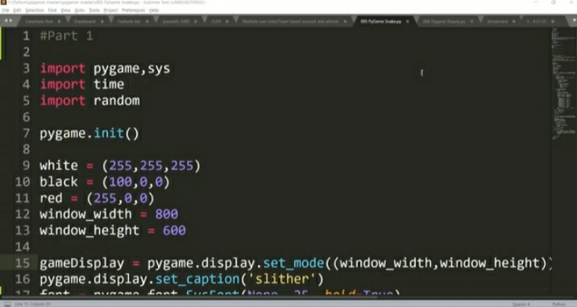

* **There is the snapshot of the certificate on competition of course.**

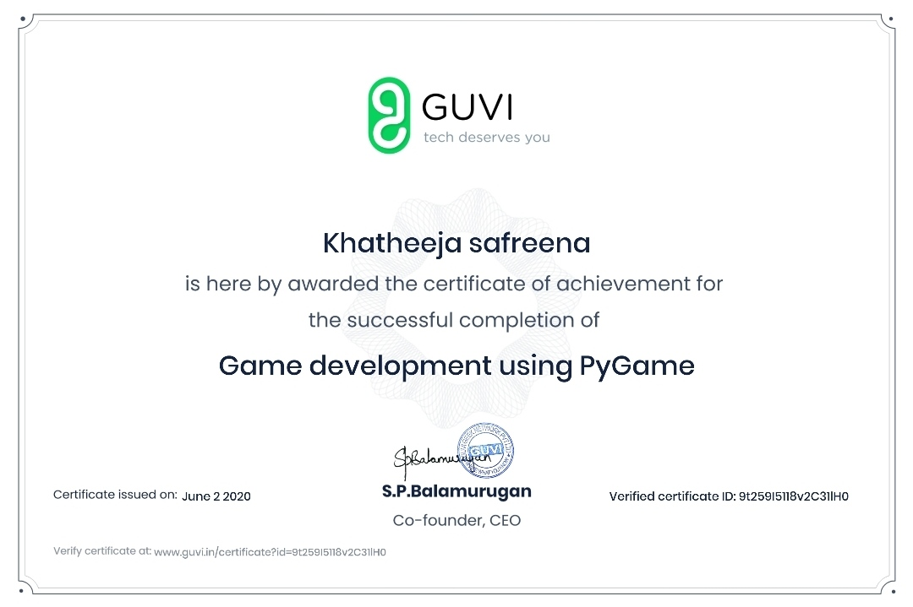

**CODING CHALLENGE:**

Today I solved 1 coding challenge,

1. **Write a Java Program to find the duplicate characters in a string.**

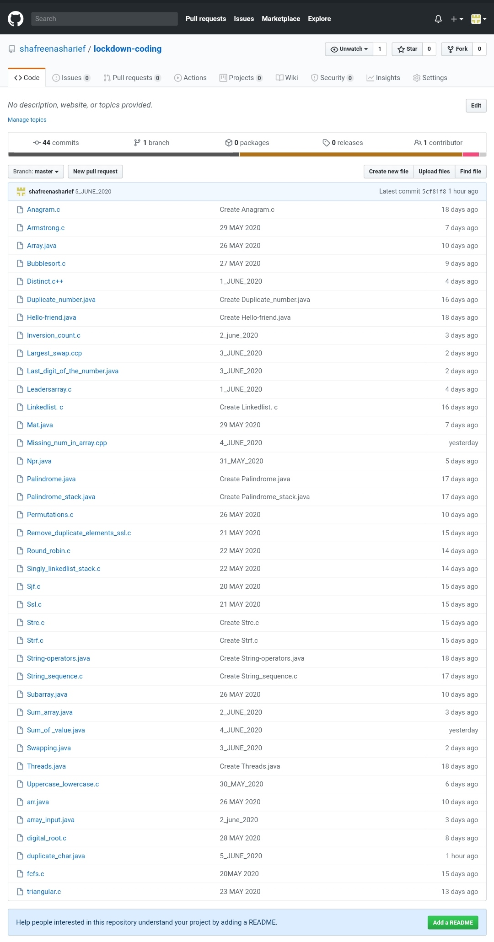

**SOLUTION : I have uploaded the solution of the above 3 coding problems in my GitHub repository.**

**http://shafreenasharief / lockdown-coding**

**http://shafreenasharief / locked-down--certification-course**

**http://shafreenasharief / Daily\_Report**